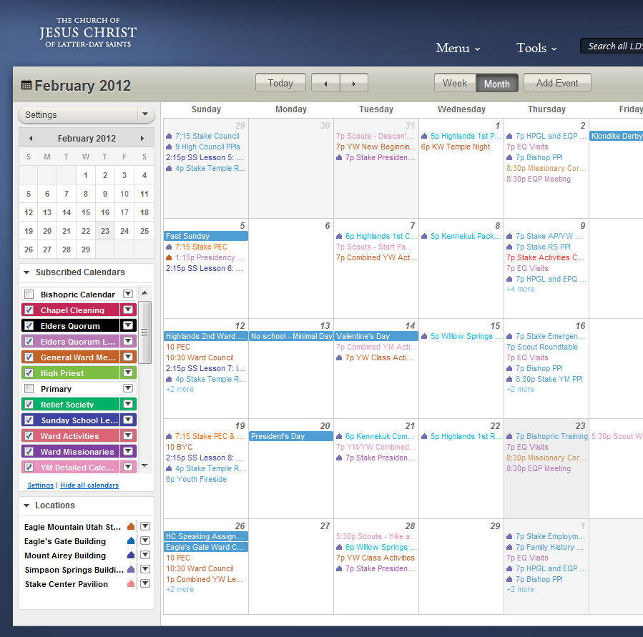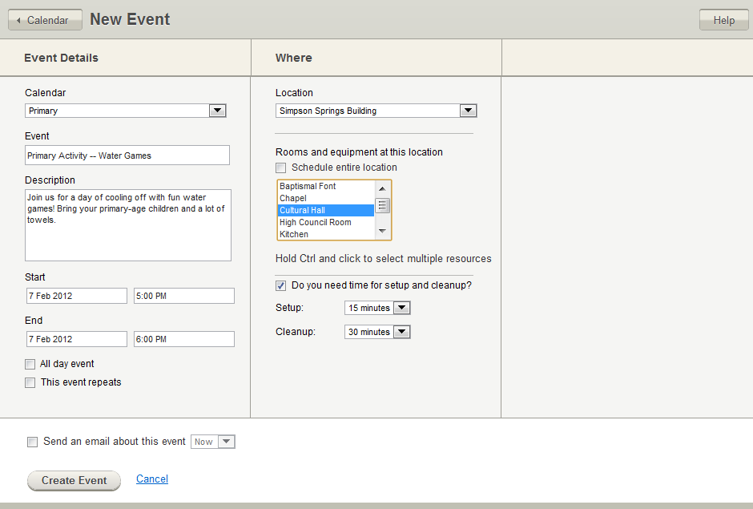3

To change the image, right-click and select **Change Picture**. You can have multiple windows here as needed. Make sure you don’t include any member information on screenshots.

Application Name

**TASK TITLE. INCLUDE AN ACTIVE VERB**

You can move these task descriptions up and down as needed. Try to keep about the same space between each description. You can move the numbers too – just move your mouse over the number until a crosshairs cursor appears, and then drag it into place.

This is a general description of the application. Space is limited here, so provide a few details about the purpose of the application, its audience, how to access the app, and any other overview type details. You can shrink or expand this section a bit, but we want to follow some general conventions with these guides so they all somewhat look the same. As such, keep this section about the same length as the other guides.

**TASK TITLE. INCLUDE AN ACTIVE VERB**

Remember that these tasks are getting started tasks, and so you want to keep them sequential if possible. Your purpose is to introduce the user to the application, not to provide advanced training.

**TASK TITLE. INCLUDE AN ACTIVE VERB**

Add a description of the task here. The number here should correspond with a number on the screenshot. It can get tricky if the number doesn’t match up with the feature, but try your best.

On LDS.org, click ….

GETTING STARTED

Tagline