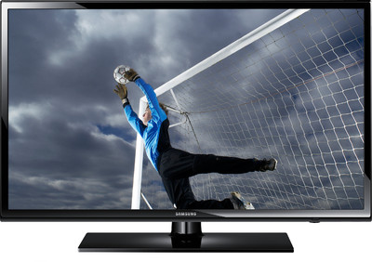
Introduction
This document explains how to:
- Play or show media files on the Samsung 4003 LED flat screen TV located upstairs at the Calgary Alberta Stake Center in the materials closet next to the High Council room.
- Save video, audio and photo files to a USB stick to later play or show on the Samsung 4003 LED flat screen TV.

Table of Contents
Introduction 1
Start the Samsung 4003 LED TV 2
Play video files on the Samsung 4003 LED TV 4
Copy media files to a USB stick 5
Show photo files on the Samsung 4003 LED TV 8
Play audio files on the Samsung 4003 LED TV 10
Add background music to slide shows 11
File type considerations 12

Where these instructions do not apply
These instructions do not apply to the:
- Other LCD or LED flat screens available for use at the Calgary Alberta Stake Center or other buildings even though these LED flat screens also have USB ports.
- Two LCD projectors available for use at the Calgary Alberta Stake Center because they do not have USB ports.

If you want to play or show the files on these other devices, you must use a laptop with an HDMI or a VGA cable.

Play time considerations
The ideal play time length of videos or a slide show in a classroom setting is four to seven minutes.

It may be useful to edit videos down to this play time where feasible. You can use Movie Maker on Windows or iMovie on a Mac to easily clip some of the video to shorten the play time to this length range.

To play a slide show for this play time will require 15 to 30 unique photos.

Start the Samsung 4003 LED TV

Step 1: Plug in the media cart
The TV is already plugged into the power bar on the media cart.

Plug the media cart power cord into a wall outlet.

Ensure the TV power light at front, bottom right corner is on.

Step 2: Insert the USB stick
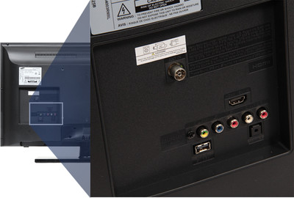
Insert the USB stick into the USB port on the back of the LED TV.

Step 3: Turn on the TV
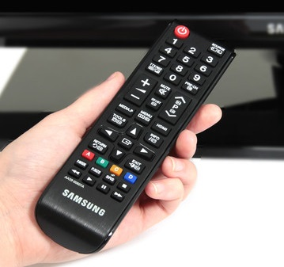
Turn on the TV by pressing the red power button at the top left of the remote.

You will hear a chime indicating the TV is turning on.

The TV does not need to be set to any particular channel to show media.

Step 4: Select the USB stick
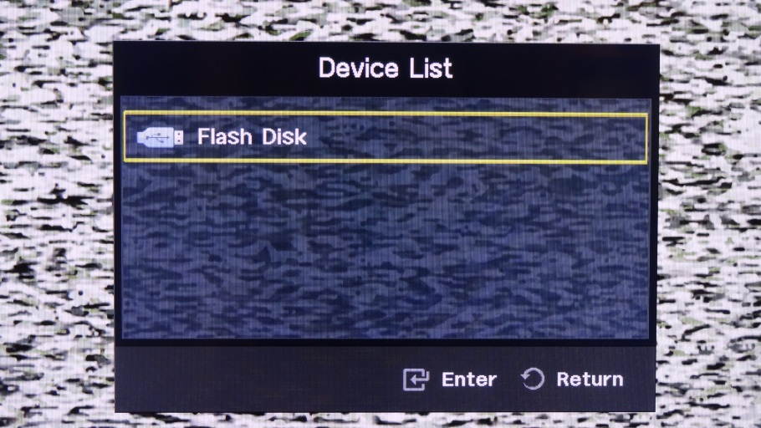
Press Enter on the remote to select the USB stick.

If the Device List dialogue box does not appear on the TV as shown at right, press the MEDIA.P button on the remote
MEDIA.P

to have the TV to sense the presence of the USB stick.

If you are not sure about how to download media files and copy them to a USB stick, read page 5 below.

Play video files on the Samsung 4003 LED TV

Step 1: Select Videos from the Media Play menu
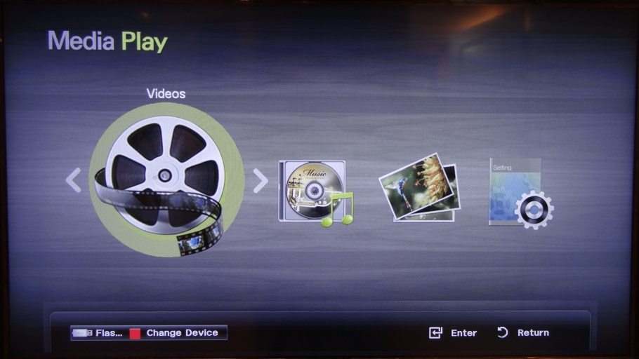
Use the left or right arrows on the remote to select Videos.

Press Enter on the remote.

Step 2: Select the video from the list
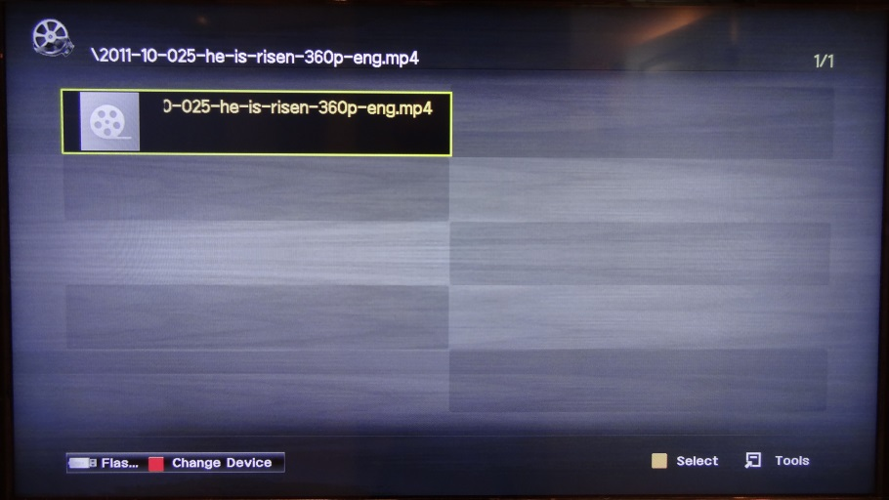
Use the up or down arrows on the remote to select the video you want to play from the list of video files available on the USB stick.

Press Enter on the remote to begin playing the video.

Only video files will appear even if the USB stick contains other media files.

Step 3: Control video play
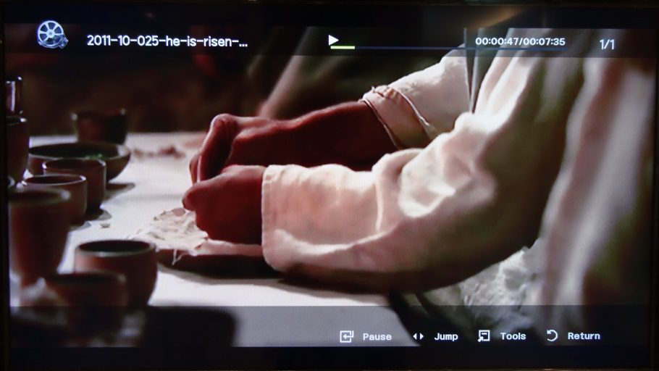
You can use the Volume +/- buttons on the remote to change the sound volume.

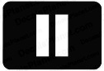
You can use the Pause button on the remote to interrupt play to discuss some aspect of the video.
You can use the Stop button on the remote to stop the video.

Press Enter to display the menu across the bottom of the screen.

Copy media files to a USB stick
This section assumes you are using a Windows computer. The Mac instructions are similar.

Step 1: Navigate to the web page
Navigate to the web page that contains the video, audio or photo file you want to use.

The examples in this document are all based on media files downloaded from lds.org.
Media files are found in many places on lds.org. Good places to find media include:
- Clicking on Additional Helpful Resources on the right side of the web page of your lesson.
- Resources > Media Library.

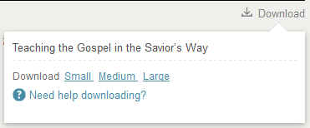
Step 2: Select file for download
Click on Download.

The Download selection dialogue box will appear.

Typically, you will click on Large for videos and photos. Audio is rarely available in multiple sizes.

While Large selects the largest file, this file will also produce the best viewing image on the LED TV.

If, for some reason, you have limited space on your USB stick, you can choose Medium or even Small.

Step 3: Download the file
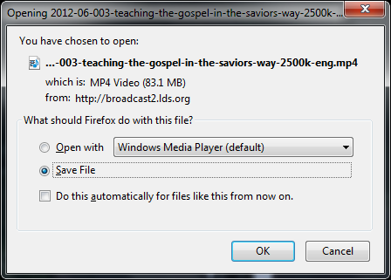
Confirm default Save File is selected.

Click on OK to start the download to computer.

This dialogue box does not appear for some brands of web browser. In this case, the file will be copied to your Downloads directory.

Depending on the brand of web browser you are using, some type of progress bar will appear during the download.

Typically the file will be copied to the Downloads directory associated with your username.

Step 4: Confirm downloaded file location
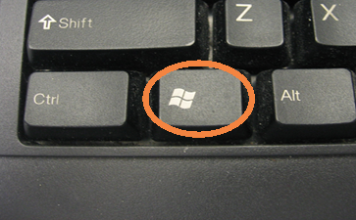
Using Windows Explorer, you can view the downloaded file list.

You can launch Windows Explorer from the Start button at bottom left of your screen or by pressing the Windows key + E.

This screen print shows how downloads for Large, Medium and Small versions of one video will appear.

Step 5: Copy downloaded file to USB stick
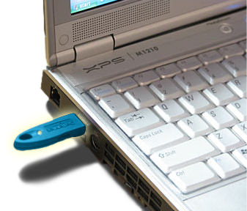
Insert USB stick into a USB port.

It advantageous to use an empty USB stick because:
- It will be easier to navigate to the file you want to show on the TV.
- The TV won’t inadvertently show photos on the USB stick that are not relevant to your lesson.

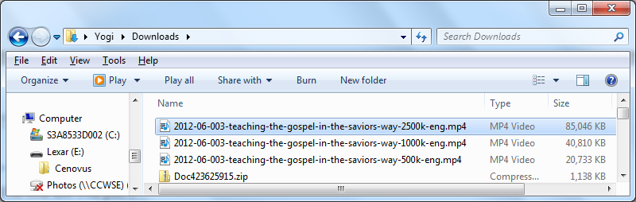

Click on the downloaded file you want to copy to the USB stick.

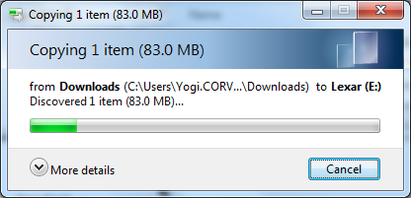
Drag the file name to USB drive letter by clicking and holding left mouse button.

Let go of mouse button. File will be copied to USB stick.

Typically this progress bar will appear during the copy.

Step 6: Confirm downloaded file exists on USB
Click on USB drive letter.

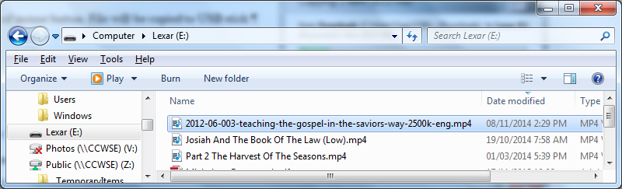

Confirm downloaded video file is shown on right.

Step 7: Eject USB stick
Right-click the USB drive letter.

Select Eject from the pop-up menu.

Remove the USB stick.

Show photo files on the Samsung 4003 LED TV

Step 1: Select Photos from the Media Play menu
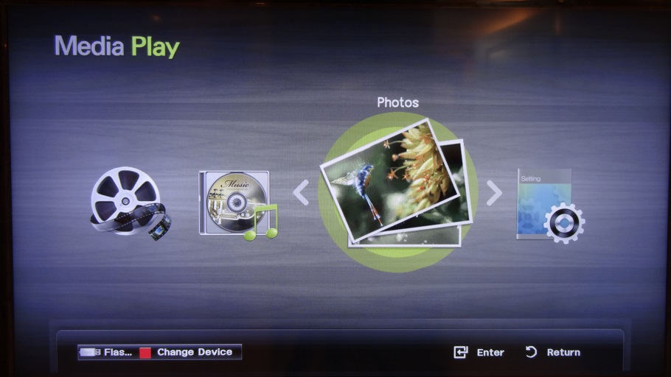
Use the left or right arrows on the remote to select Photos.

Press Enter on the remote.

Step 2: Select a photo from the thumbnails displayed
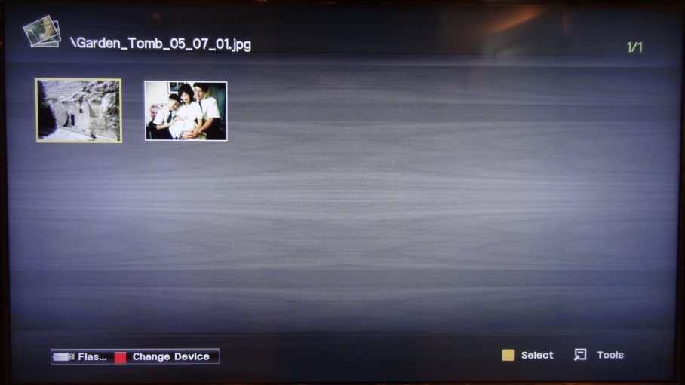
Use the up or down, left or right arrows on the remote to select the first photo you want to show from the photo thumbnails displayed.

Press Enter on the remote to begin showing the photo.

Only photo thumbnails will appear even if the USB stick contains other media files.

Step 3: Control photo show
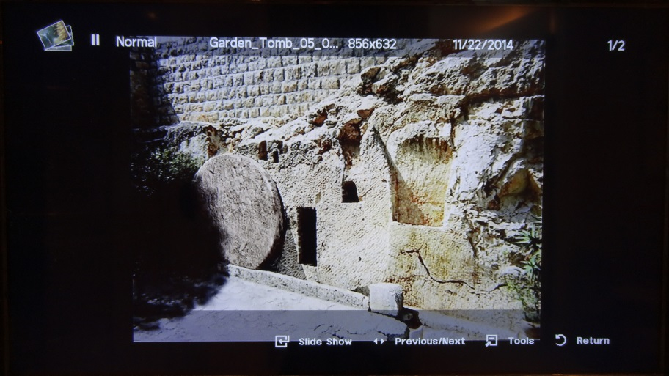
You can use the left or right arrows on the remote to select the next or previous photo.

If you do not press any keys on the remote, the TV will advance through the available photos.

Press Enter to display the menu across the bottom of the screen.

Step 4: Zoom in to increase the size of photos
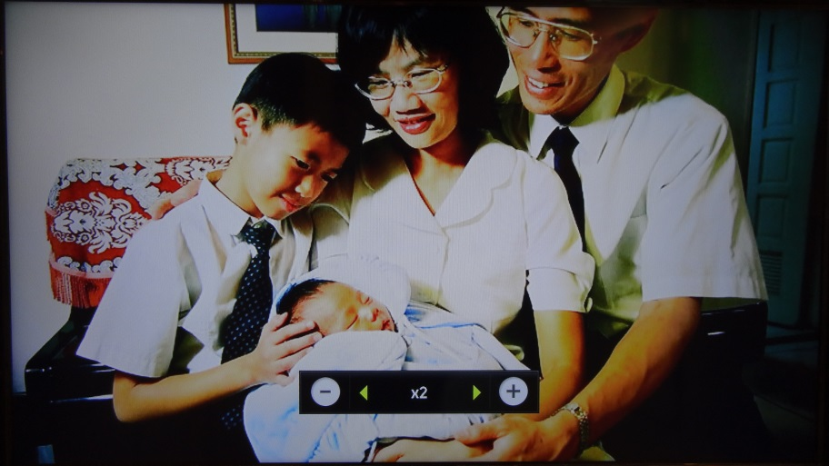
Press Tools to display the Tools menu.

Select Zoom on the Tools menu.

Press the right arrow to increase the size of the photo until it fills the screen.

The TV will display photos using their original dimensions and will automatically decrease the size of photos that are too large to fit without changing their aspect ratio. This decreasing operation will produce black bars on the left and right or top and bottom of the screen.

The TV will not automatically increase the size of photos to make better use of the screen area.

The ideal dimensions of photos that will fill the screen are 1920 x 1080 pixels.

If you’re not sure of the dimensions of your photo, use software like Microsoft Picture Manager to display the dimensions and the implied aspect ratio. You can use software to crop photos to a better aspect ratio. There is no value in resizing photos for display.

Play audio files on the Samsung 4003 LED TV

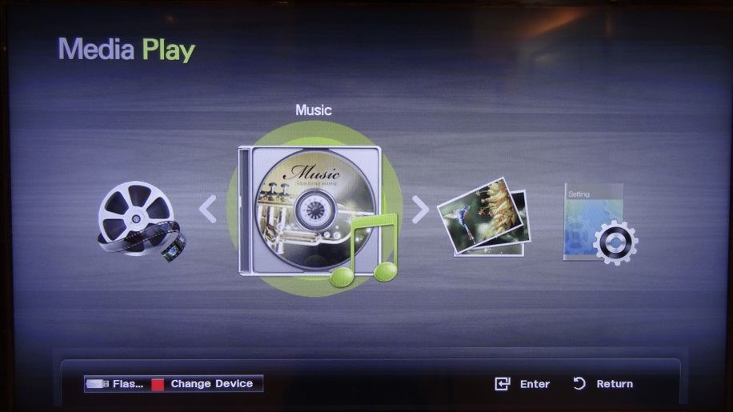
Step 1: Select Music from the Media Play menu
Use the left or right arrows on the remote to select Music.

Press Enter on the remote.

It may be easier to use a laptop, tablet or smartphone with an external speaker to play music than to use the TV.

Step 2: Select the music from the list
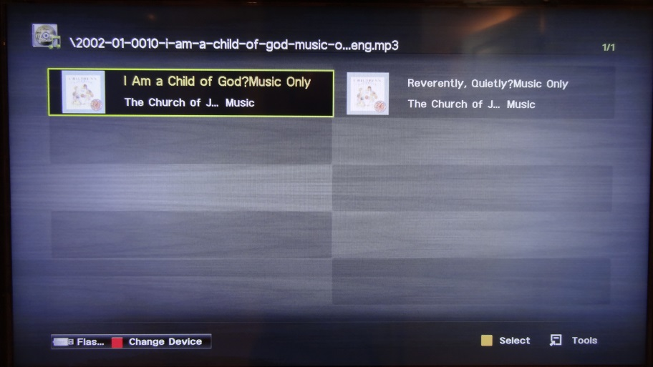
Use the up or down arrows on the remote to select the music you want to play from the list of music files available on the USB stick.

Press Enter on the remote to begin playing the music.

Only music files will appear even if the USB stick contains other media files.

Step 3: Control music play
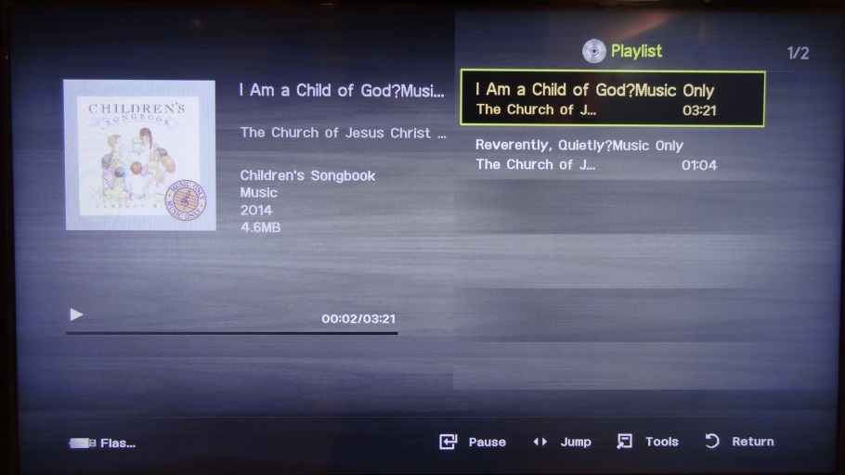
You can use the Volume +/- buttons on the remote to change the sound volume.

You can use the Pause button on the remote to interrupt play to discuss some aspect of the music.

You can use the Stop button on the remote to stop the music.

Press Enter to display the menu across the bottom of the screen.

Add background music to slide shows

Step 1: Select Photos from the Media Play menu
Use the left or right arrows on the remote to select Photos.

Press Enter on the remote.

Step 2: Select Background Music feature
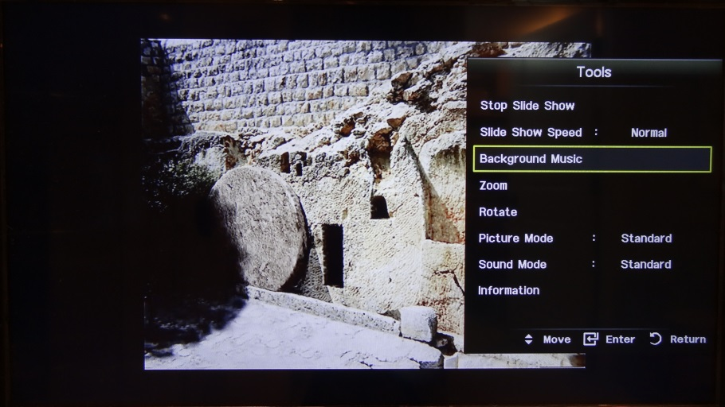
Press Tools to display the Tools menu.

Use the down arrow on the remote to select Background Music.

Press Enter on the remote.

Step 3: Turn on Background Music
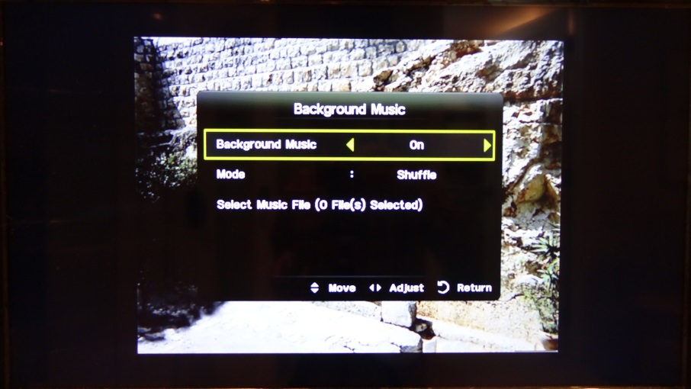
Press the right arrow to turn On Background Music.

Step 4: Set up Background Music
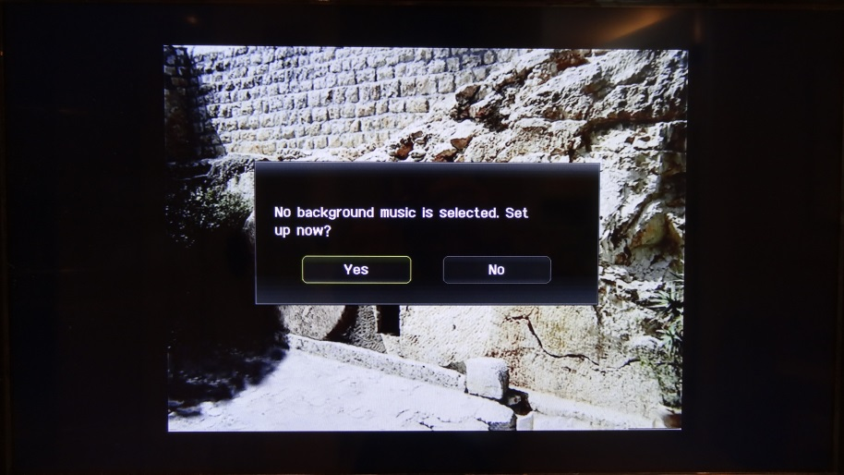
Press Enter on the remote to set up background music.

Step 5: Select Background Music file
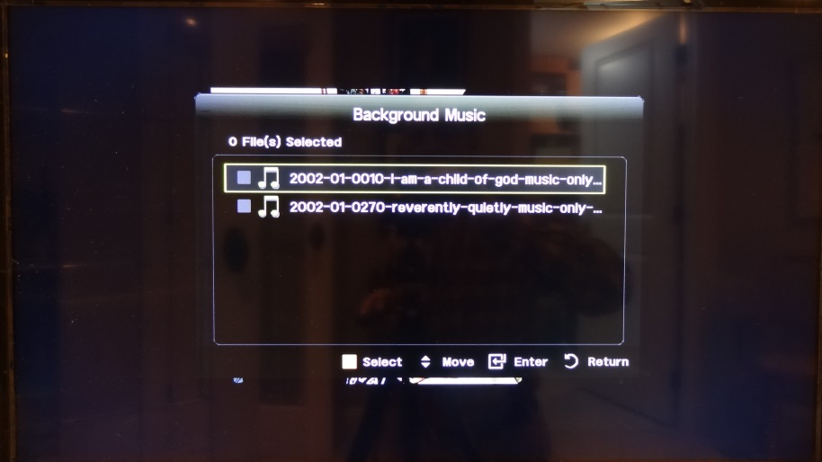
Use the up or down arrows on the remote to select the background music file.

Press Enter on the remote to begin playing the background music.

File type considerations
The LDS church’s website offers media using the following file types:

Media type | File extension | Samsung 4003 capability
Video | .mp4 | Yes
Audio only | .mp3 | Yes
Photos | .jpg | Yes
Text | .pdf or .html | No

The Samsung 4003 can:
- Also play video files with many other file types. See page 10 of the LED TV user manual attached behind this document. You may encounter these other video file types at other websites.
- Show a series of photos as a slide show. Optionally, The Samsung 4003 can play an audio file as background music with the slide show.
- Only show PowerPoint presentations using a laptop with an HDMI cable. The alternative is to make use of the slide show feature described above, perhaps using the PowerPoint Save As .jpg feature.

